CA-1

INT233

Data Visualization

Name: Yendluri Pavan Ram Chandar

Reg No:12003141

Roll No:40

Section:KM027

1. Use “matches” dataset and find which of the following years is having highest DI applied.
2. 2014
3. 2015
4. 2016
5. 2017

Ans:2016

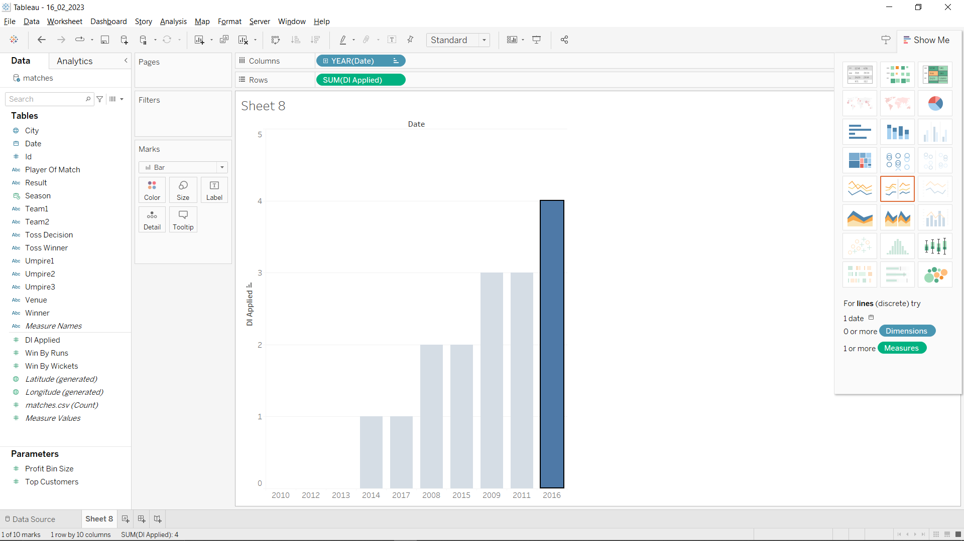

1. Use “matches” dataset and find how many seasons are played at Rajiv Gandhi International Stadium, Uppal.
2. 98649
3. 6027
4. 8066
5. 30243

Ans:98649

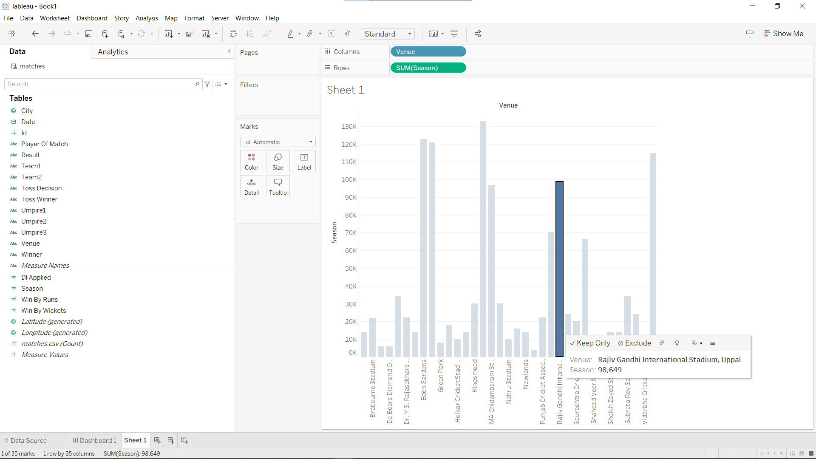

1. Use “matches” dataset and find which of the teams from team 1 have won maximum matches by wicket.
2. Gujarat Lions
3. Chennai Super Kings
4. Kings XI Punjab
5. Mumbai Indians

Ans:a

1. Use “matches” dataset and find which of the teams from team 2 have won minimum matches by runs.
2. Royal Challengers Bangalore
3. Rising Pune Supergiants
4. Gujarat Lions
5. Rajasthan Royals
6. Use “Netflix” dataset and find how many movies (Type) are there on Netflix.
7. 5000
8. 5230
9. 5377
10. 5567

Ans:c

1. Use “topSubscribed” dataset and find which of the following category is having lowest rank.
2. Entertainment
3. Gaming
4. Pets and Animals
5. Trailers

Ans:d

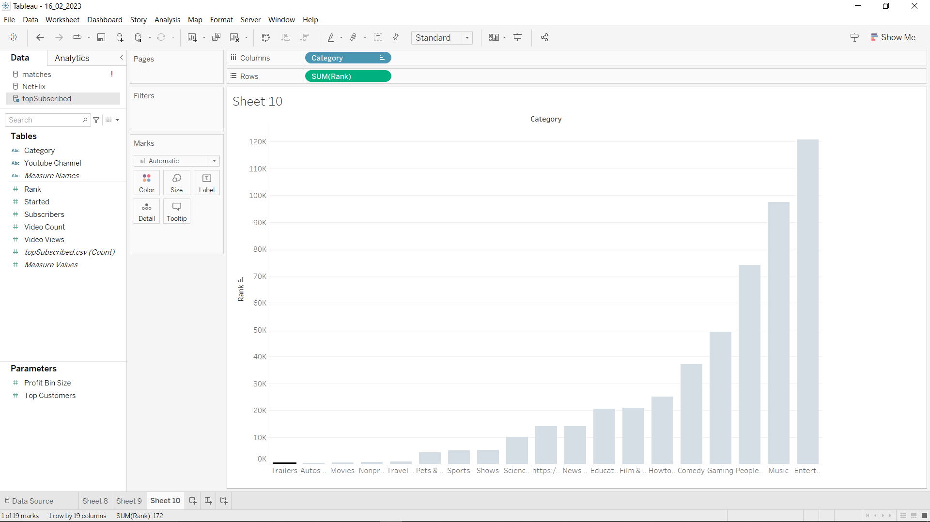

1. Use “topSubscribed” dataset and find how many subscribers are there for Wow Kids channel.
2. 35200000
3. 24900000
4. 29900000
5. No such channel is there

Ans:

No column with that name

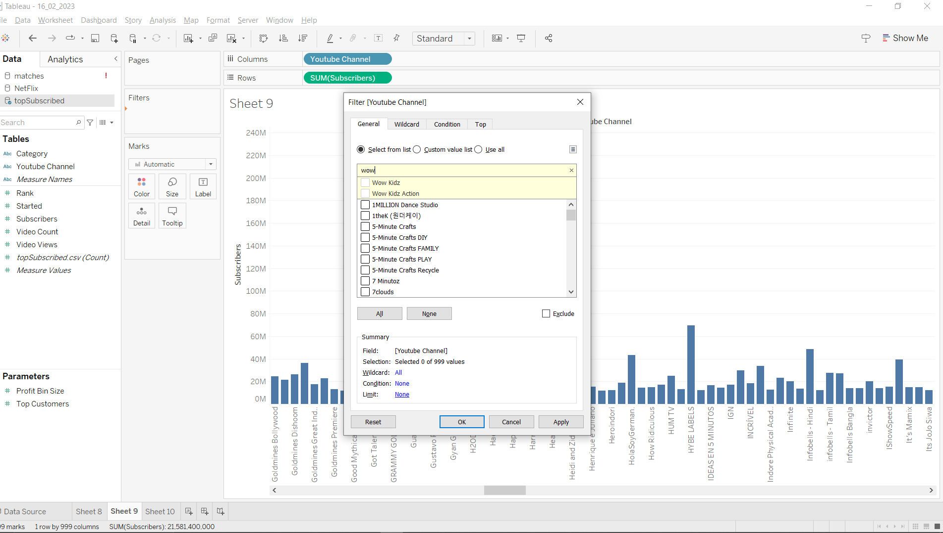

1. Use “topSubscribed” dataset and find total video count of Entertainment, News & Politics and People & Blogs as a group.
2. 2184262
3. 7231966
4. 7184321
5. Not possible to find the total video count for a group

Ans:b

1. Use “topSubscribed” dataset and find which of the categories is having highest and lowest count of topsubscribed.
2. Music and Trailers
3. Entertainment and Travel & Events
4. Entertainment and Autos & Vehicles
5. Music and Travel & Events

Ans:b and c

1. Use “matches” dataset to find the average of win by runs for Sunrisers Hyderabad.
2. 11.09
3. 17.09
4. 3.29
5. 0.00

Ans:11.3

1. Use “bike_dataset” and find the minimum mileage for electric bike.
2. 6360
3. 9770
4. 45.00
5. 8.00

Ans:45.00

1. Using “bike_dataset” find the average price of Ather 450 model name.
2. 118995
3. 50000
4. 38719
5. None of these

Ans:118995

1. Using “Fifa_world_cup_matches” dataset, find the minimum number of switches of play completed team 1 for Brazil in Team 1.
2. 1
3. 4
4. 5
5. 6

Ans:6

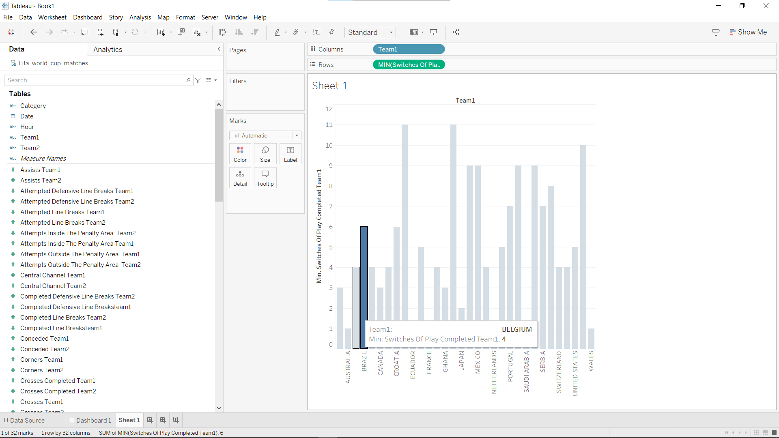

1. Using “fifa_world_cup_matches” dataset, find the count of assists Team 2 for Spain in Team 2.
2. 0
3. 1
4. 2
5. 3

Ans:2

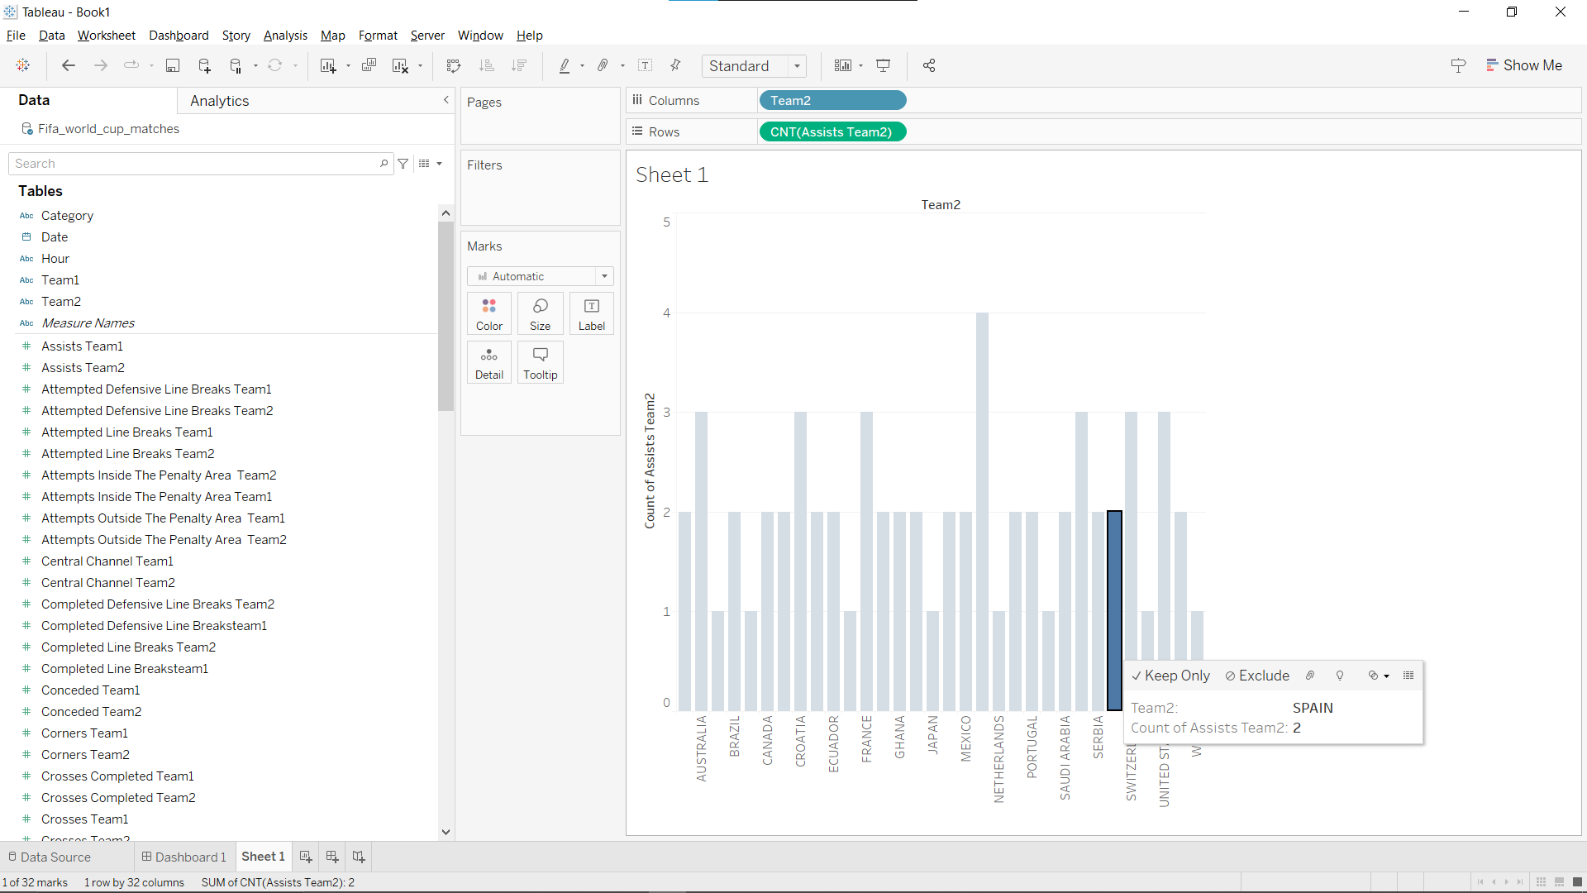

1. Using “fifa_world_cup_matches” dataset, find the total free kicks team 1 for group of Argentina, Croatia and England of Team 1.
2. 195
3. 700
4. 556
5. 202

Ans:202

